Chapter 12 – Laws covered in this chapter

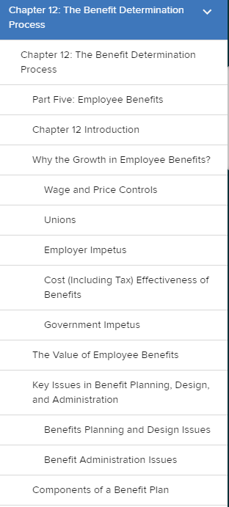

LOOK ON NEXT PAGE
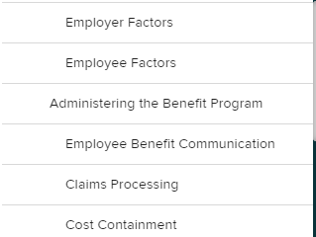

LOOK ON NEXT PAGE

Chapter 13 – Laws covered in this chapter

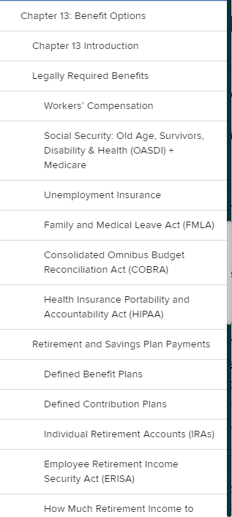
LOOK ON NEXT PAGE
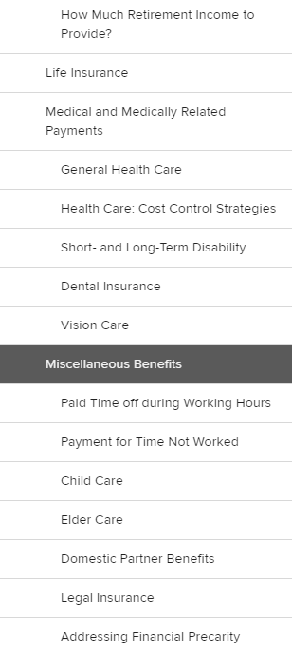

LOOK ON NEXT PAGE
Chapter 17 – Laws covered in this chapter
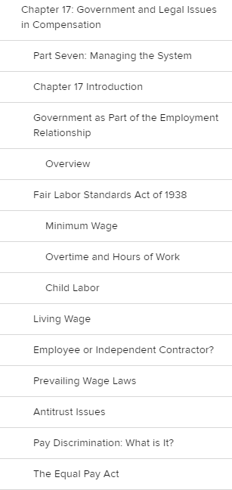
LOOK ON NEXT PAGE

